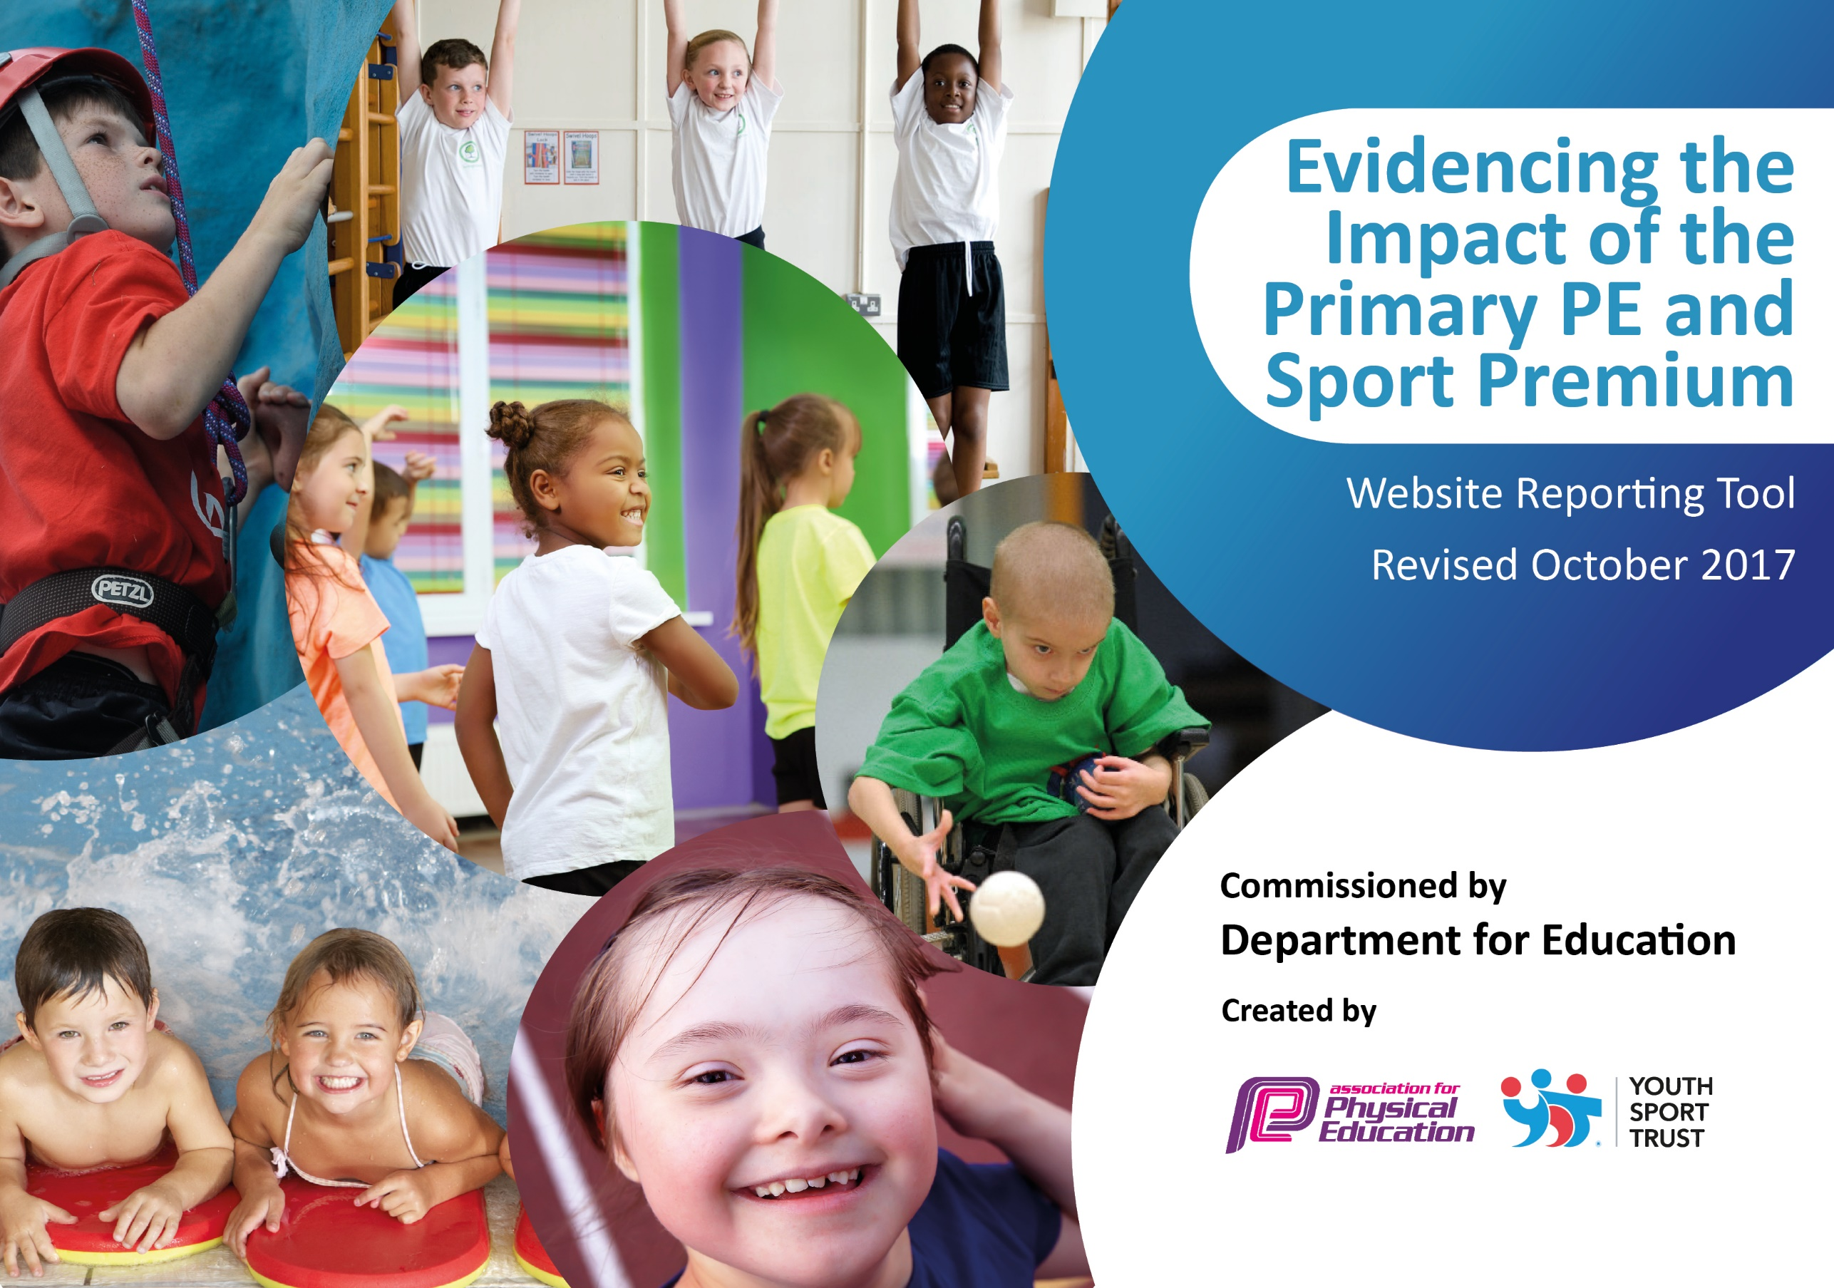

Schools must use the funding to make additional and sustainable improvements to the quality of PE and sport they offer. This means that you should use the Primary PE and Sport Premium to:

- develop or add to the PE and sport activities that your school already offers
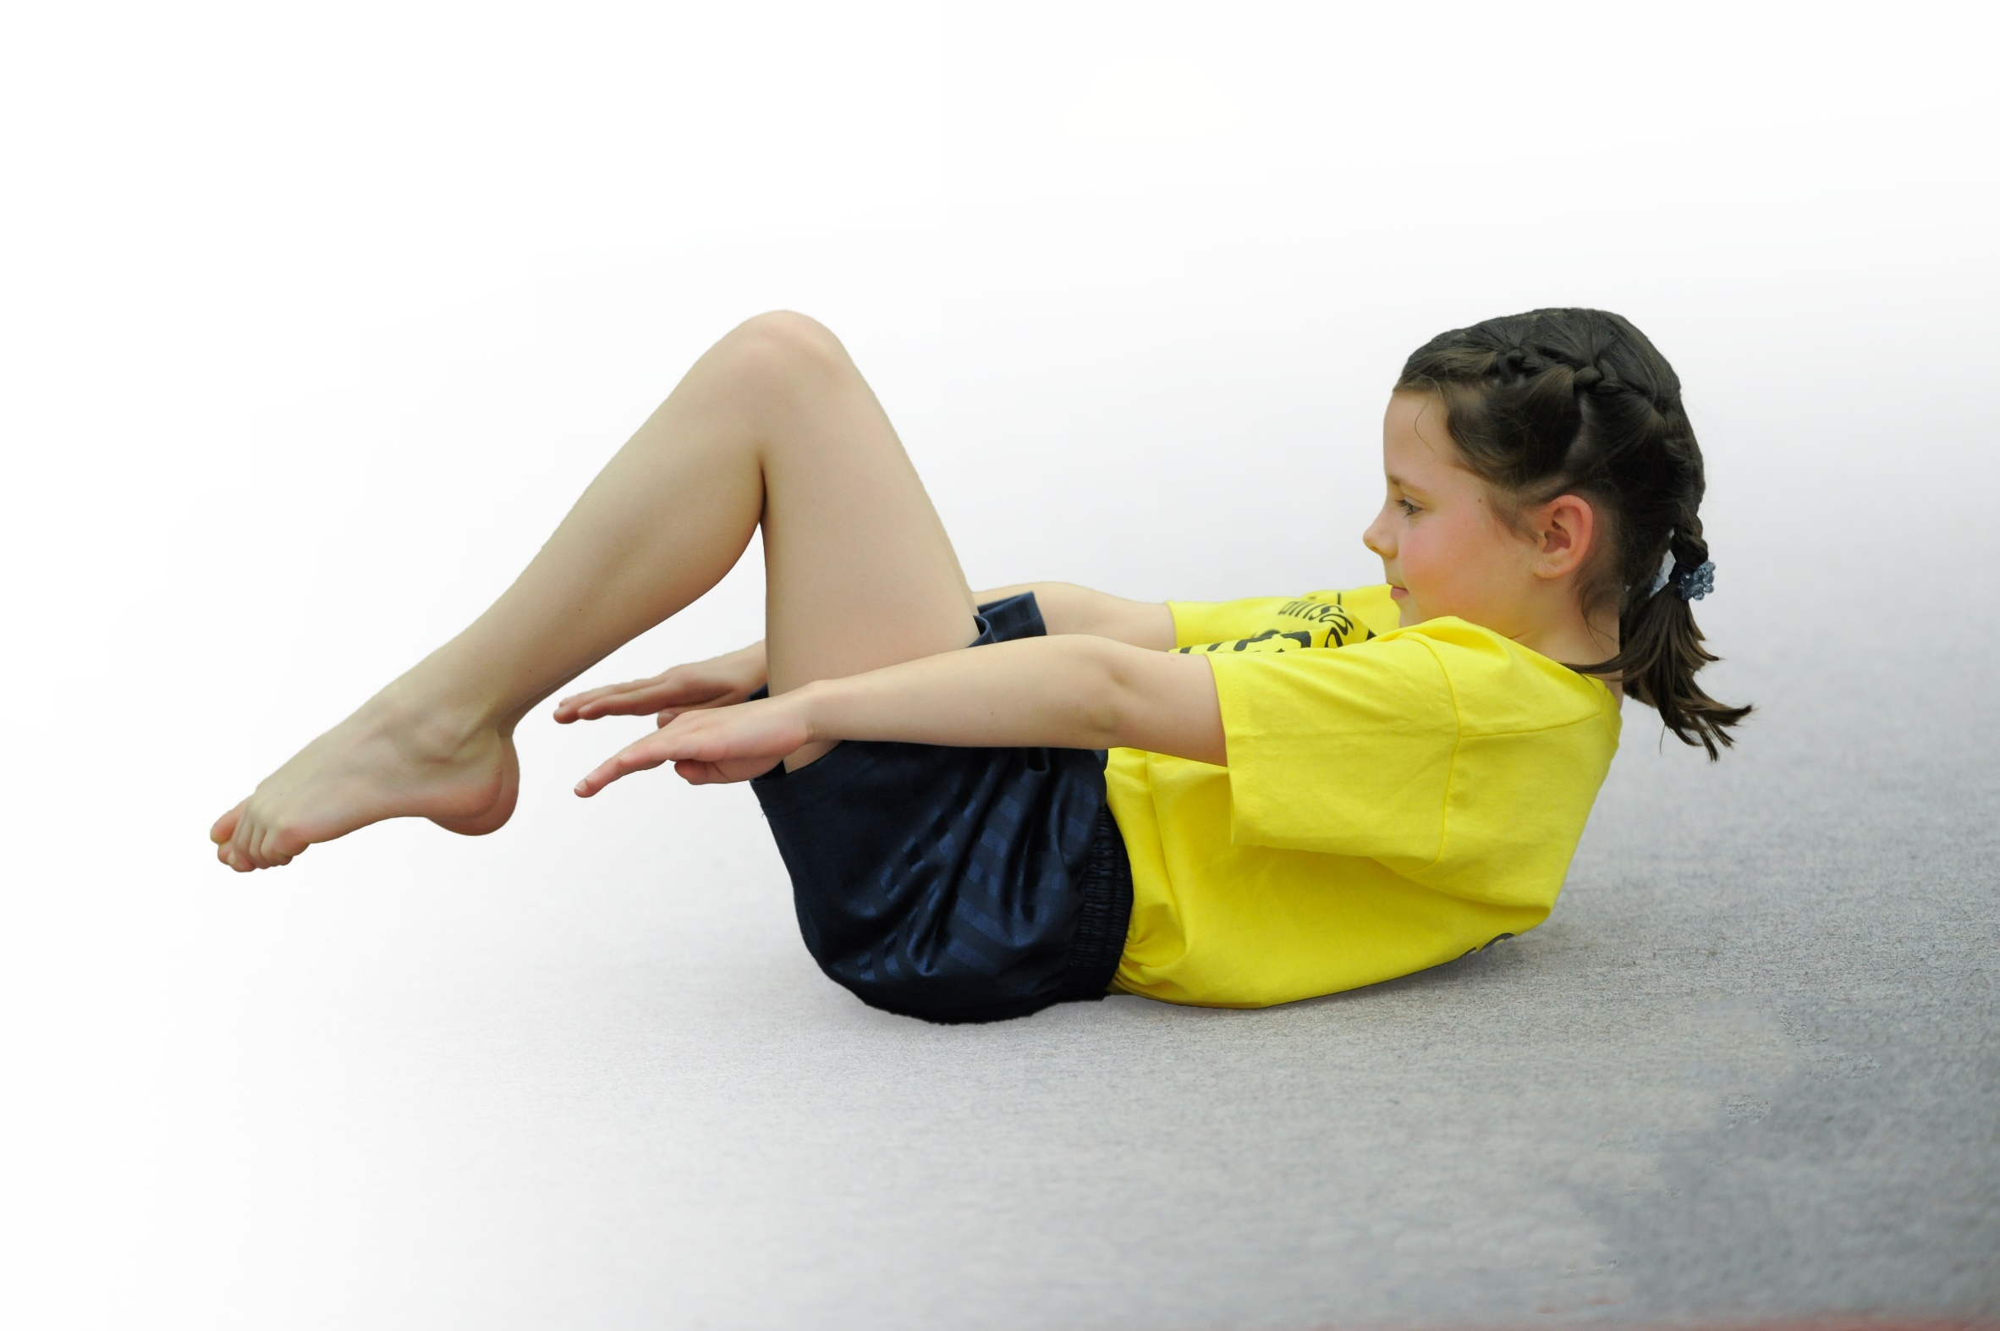
- build capacity and capability within the school to ensure that improvements made now will benefit pupils joining the school in future years

Please visit gov.uk for the revised DfE guidance including the 5 key indicators across which schools should demonstrate an improvement. This document will help you to review your provision and to report your spend. DfE encourages schools to use this template as an effective way of meeting the reporting requirements of the Primary PE and Sport Premium.

We recommend you start by reflecting on the impact of current provision and reviewing the previous spend.
Under the Ofsted Schools Inspection Framework, inspectors will assess how effectively leaders use
the Primary PE and Sport Premium and measure its impact on outcomes for pupils, and how effectively governors hold them to account
for this.

Schools are required to publish details of how they spend this funding as well as on the impact it has on pupils’ PE
and sport participation and attainment.
We recommend regularly updating the table and
publishing it on your website as evidence
of your ongoing review into how you are using the money
to secure maximum, sustainable impact. To see an example of how to complete the table please click HERE.

Support for review and reflection - considering the 5 key indicators from DfE, what development needs are a priority for your setting and your students now and why? Use the space below to reflect on previous spend, identify current need and priorities for the future.

2023/24
Key achievements to date: | Areas for further improvement and baseline evidence of need:
- Each class participates in 2 hours of PE a week.  - Rollout of additional Cross Curricular Orienteering resources for all year groups facilitating greater outdoor learning, teamwork and fitness  - Continued expansion of the number and variety of After-School Clubs in sport and dance (now returned to pre-Covid levels).  - Major improvement to playground with the purchase of an activity fence featuring 5 zones to encourage more active physical activities by all children (used at playtimes on a rota basis and in P.E. lessons)  - Involvement of high quality external coaches – Accrington Stanley Community Trust, Dave Varey, Lancashire Cricket, Sportscool, KICK.  - Pupil Parliament providing leadership and securing funding for playtime / lunchtime activities.  - Successful participation in a range of inter-school sports competitions.  - Access to sports equipment for all classes at lunchtime breaks.  - Work closely with swimming coaches at Accrington Academy to ensure that every child is supported in learning to confidently swim 25 metres, use a range of different strokes and perform safe self-rescue.  - Ensure that children are safe on the road with Bikeability.  - Improve Reception children’s confidence through Tots on Tyres.  - Promote the Gifted and Talented (children at a number of professional football club’s academies, gymnastics & dance organisations).  - Learning Journeys (12 per class per year) rolled out across school, linked to Lancashire Educations P.E. Passport scheme of work. | - Further work needed to embed Cross Curricular Orienteering scheme of work in all classes.  - Provide greater opportunities for children to participate in dance and gymnastic based activities both within the school curriculum and extra-curricular clubs / events.  - Reestablish and reinforce the importance of the ‘Daily Mile’ for all classes.  - Staff training / Twilight sessions to embed P.E. Passport scheme of learning and use of the system to improve planning, assessment and evidencing learning.  - Monitoring of 30 active minutes per day (minimum).  - Implementation of Learning Outside the Classroom across the curriculum, including Forest School activities for all year groups.  - Increased participation in inter-school competitive sports (will require wider staff involvement).  - Use of Sports Premium funds to provide booster sessions for swimmers requiring further support in small groups.
Meeting national curriculum requirements for swimming and water safety |  | Please complete all of the below:
What percentage of your Year 6 pupils could swim competently, confidently and proficiently over a distance of at least 25 metres when they left your primary school at the end of last academic year? |  | 80
What percentage of your Year 6 pupils could use a range of strokes effectively [for example, front crawl, backstroke and breaststroke] when they left your primary school at the end of last academic year? |  | 80
What percentage of your Year 6 pupils could perform safe self-rescue in different water-based situations when they left your primary school at the end of last academic year? |  | 84
Schools can choose to use the Primary PE and Sport Premium to provide additional provision for swimming but this must be for activity over and above the national curriculum requirements. Have you used it in this way? |  | Yes / No  Funds allocated for extra sessions in Summer 2, aimed at a small group (max 12) of swimmers in Years 5 & 6 requiring further support.

Action Plan and Budget Tracking
Capture your intended annual spend against the 5 key indicators. Clarify the success criteria and evidence of impact that you intend to measure to evaluate for students today and for the future.

Academic Year: 2023/24 | Total fund allocated: £18,000 | Date Updated: 22-07-24
Key indicator 1: The engagement of all pupils in regular physical activity – Chief Medical Officer guidelines recommend that primary school children undertake at least 30 minutes of physical activity a day in school. |  |  |  | Percentage of total allocation:
%
73
School focus with clarity on intended impact on pupils: | Actions to achieve: | Funding allocated: | Evidence and impact: | Sustainability and suggested next steps:
Redesign playground – resurfaced sports area, netball/basketball nets erected, play markings for KS1, clearance/removal of obstacles to extend active area, installation of benches/tables for outdoor learning | Increased use of facilities during playtime, lunchtime, P.E., after-school clubs and active outdoor learning. Improved wellbeing and access to outdoor facilities at all times. |  | Monitoring of each class’s use and extent of active time.  Monitor how the new sports zone is used in P.E. lessons and by after-school clubs. | Improved use of equipment to enhance P.E. lessons.  Allocation of equipment such as bean bags, balls, hoops to each class to allow ad-hoc utilization of this resource.
Regular physical education curriculum – develop fitness, coordination skills, teambuilding. | 2 hours PE weekly. | 1,212 | Timetable, Planning.  Children more active and skills developed in core PE areas | Continue to purchase specialist coaches and CPD.  Improve & replenish resources.
To ensure that all pupils are engaged in regular physical activity and undertake 30 minutes physical activity every day. | Establish and embed the Daily Mile project within school. |  | Use timetables to ensure that Daily Mile is being delivered and children’s fitness should improve further. | Continue to monitor the 30 minutes physical activity.
To engage all pupils in physical outdoor activity with the purchase of Cross Curricular Orienteering resource. Extension materials purchased. | To offer a range of Outdoor and Adventurous Activities through after school clubs and within the PE curriculum. | 800 | Medium term & Long term planning should include Outdoor and Adventurous Activities. This will engage all pupils. | Monitoring of Long / Medium Term plans.  Evaluation of impact.
To engage all pupils in some fun physical activity and tackle obesity. | To encourage children to participate in daily playtime and lunchtime physical activities. | 770 | Sportscool / KICK and staff-led organised sessions at lunchtime.  All classes participating. | Continue to monitor the impact of physical well-being of children.
To engage all pupils in a variety of physical activity. | To offer a range of extra-curricular activities in conjunction with Sportscool / FUNDA, other external specialist providers and local secondary schools.  All children invited to feedback on activities offered and what they would like to see included. | 5,225 | Through timetabling extra- curricular activities in the year planner and through website reports and notices, this will engage more pupils to participate in sport.  Specific focus on responding to children’s opinions / suggestions by introducing new activities. | Continue to monitor the interest in a range of sport and bring in fresh skills and interests in the future.
To ensure that children are physically active in a range of sport and to ensure that children in Year 4-6 build on life saving skills in swimming lessons. | Swimming and water safety lessons. | 2,424 | Swimming has been timetabled on the yearly planner. All pupils supported in swimming at least 25 metres.  Booster sessions for those requiring further support scheduled for Summer 2. | Continue to monitor the ability in swimming and value for money.
To ensure that the youngest children have the opportunity to learn a balancing skill that will eventually teach them how to ride a bike. | To teach balance bikes with Reception children through Tots on Tyres. | 600 | The children have gained a new skill and are on their way to learning how to ride a bike. This was timetabled in during the Autumn term. Reports will be provided in newsletters. | Continue to monitor the impact of the Balance Bikes and look into purchasing some for use in Reception outdoor area.
To ensure that the children that are nearly ready for high school are aware of safe means to travel on a bike on the roads. | To teach Year 6 Bikeability. |  | The children have gained a new skill and know how to ride a bike safely on the roads. This was timetabled in during the Autumn half term. Reports/certificates issued. | Continue to monitor the impact of Bikeability.
To engage all including those with special needs in physical activities. | Use of resources suitable for all ages and abilities (e.g. New Age Kurling and Boccia kits). | 450 | The school has entered competitions in the year which includes those for Special needs. This has helped to boost the confidence of those  children. Reports will be listed on the website and in newsletters. | Continue to monitor the impact of competitions and inclusion.
To ensure that school has the necessary equipment to effectively teach physical activities. | Increase use of high-quality equipment (purchased in previous year) for Handball, Dodgeball, Football, Netball, Basketball, Rugby, Athletics and Orienteering. | 491 | More active participation in sports like football, dodgeball and athletics for all pupils. | Continue to check and ensure that equipment is available for range of PE activities and sports.
To ensure that school has the necessary equipment to effectively teach physical activities including Gymnastics. | To purchase and repair Gymnastics equipment. |  | More active participation in sports like gymnastics for all pupils. | Continue to check and ensure that equipment is available for PE.
To ensure that children have opportunities to participate in Dance and attend regular dance-based after school clubs led by specialist dance coaches. | To offer a minimum of 3 dance-based after school clubs during the year (Street Dance, Cheerleading, Zumba). | 1,200 | More active participation in dance activities for all pupils. | Continue to check and ensure that equipment is available for Dance.
Key indicator 2: The profile of PE and sport being raised across the school as a tool for whole school improvement |  |  |  | Percentage of total allocation:
 |  |  |  | 1
School focus with clarity on intended impact on pupils: | Actions to achieve: | Funding allocated: | Evidence and impact: | Sustainability and suggested next steps:
To effectively train the older children in leadership skills. To train children in a variety of games for play time. | To work with the Pupil Parliament and train Young Leaders to organise and play games at break time with other children. |  | At play times a variety of games are on offer to engage all pupils and the older ones build on their leadership skills through the delivery of it. | For the Pupil Parliament and Leaders meetings to evaluate the successes and areas to improve.
To raise the profile of PE in school and encourage as many people as possible to participate. | PE and Sports news is reported on the school website and regular newsletters. |  | Latest reports will be listed on the website and in newsletters. | To continue to monitor and update the website.
To raise the profile of PE in school and encourage as many people as possible to participate. | School sport is reported, and regularly updated, on the PE Information Board. |  | Latest reports will be listed on the PE Information Board (including details of upcoming events and clubs) and on the website. | To continue to monitor and update on the PE Information Board and website.
To raise the profile of PE in school and encourage as many people as possible to participate. | Trophies are displayed in the entrance sports cabinet.  Certificates of participation and achievement presented in Key Stage assemblies. | 200 | Through updating the entrance with the latest awards and certificates. | To ensure that the latest achievements are displayed.
To raise the profile of PE in school and encourage as many people as possible to participate. | Celebrate participation and achievements of children in sport and dance activities outside of school in Key Stage assemblies. |  | Create a display of evidence (photographs, trophies, medals, certificates) of participants in sporting activities to raise profile of sports and awareness of the variety of opportunities to children. | Remind and encourage children to share their experiences and achievements in class and assemblies (including Gifted & Talented).

Key indicator 3: Increased confidence, knowledge and skills of all staff in teaching PE and sport |  |  |  |  | Percentage of total allocation:
 |  |  |  |  | 10
School focus with clarity on intended  impact on pupils: | Actions to achieve: | Funding  allocated: |  | Evidence and impact: | Sustainability and suggested  next steps:
To increase confidence & knowledge for all staff teaching PE and Sport. | CPD support from Sportscool, and FUNDA staff training / Twilight sessions and attendance on Lancashire courses for KS1 and KS2. | 1,188 |  | Following the CPD given, observations of lessons and monitoring of plans will take place to ensure all staff are confident at delivering the new curriculum and utilise the range of resources available. | Monitoring of PE lessons.  Increase opportunities for sport within lessons to encourage children to use / develop skills within the context of competitive sport. Continue to purchase the specialist coaches and CPD.
To increase confidence and knowledge for all staff for to teach the Daily Mile. | Daily Mile to be established within all classes. |  |  | The Daily Mile will be timetabled and the staff will be confident in its delivery to ensure children’s improved fitness. | To monitor and ensure the progress made by the Daily Mile.
To update and maintain resources to assist staff in teaching effective PE. | To use the Lancashire PE scheme and a variety of available resources / teaching materials to create variety and fun in teaching PE.  Increase use of sport-specific equipment within lessons to develop and extend skills. | 640 |  | Through half termly monitoring of the PE plans and notes, PE will be taught effectively. | To monitor and ensure Medium Term Plans cover all aspects of PE. Continue to purchase the specialist coaches and CPD.
To increase confidence and knowledge for all staff for teaching PE and Sport. | To send staff on LCC CPDs |  |  | Through half termly monitoring of the PE plans and notes, PE will be taught effectively. | To monitor and ensure all staff are proficient in teaching PE. Continue to purchase the specialist coaches and CPD.
Key indicator 4: Broader experience of a range of sports and activities offered to all pupils |  |  |  |  | Percentage of total allocation:
 |  |  |  |  | 16
School focus with clarity on intended  impact on pupils: | Actions to achieve: | Funding  allocated: | Evidence and impact: |  | Sustainability and suggested  next steps:
To offer a broader experience of a range of sports and activities offered to all pupils, through partnership with external coaches, staff-led activities and specialist providers.  Enter a wider variety of cluster events and other inter-school competitions. | To participate in a wider variety of sporting activities and enter competitive events. |  | This has helped to boost the confidence of children. Reports will be listed on the website and in newsletters. Registers of pupils are also taken. |  | Monitor the sustainability of pupils and report on the range of sport provided.
To offer a broader experience of a range of sports and activities offered to all pupils (including New Age Kurling, Hockey, Tennis, Basketball and Handball) | To offer an increased number and range of after school sporting clubs from Reception to Y6.  Target new activities at less active children to widen participation. | 2,800 | This has helped to boost the confidence of those children. Reports will be listed on the website and in newsletters. Registers of pupils are also taken. |  | Monitor the sustainability of pupils and report on the range of sport provided.
To enhance the skills in sport for the more able pupils. | Identify and support Gifted and Talented children.  Work with local secondary schools and external organizations to improve their abilities. |  | This has helped to challenge those children. Reports will be listed on the website and in newsletters. |  | Monitor the sustainability of pupils and report on the achievements of the pupils.
Encourage more girls to participate in football. | To train the girls in football through Sportscool and work with Blackburn Rovers and Accrington Stanley to improve skills and participate in local events.  . |  | This has helped to boost the confidence of those children. Reports will be listed on the website and in newsletters. Registers of pupils are also taken. |  | Monitor the sustainability of pupils and report on the range of sport provided. Continue to promote after school activities.
Key indicator 5: Increased participation in competitive sport |  |  |  |  | Percentage of total allocation:
 |  |  |  |  | -
School focus with clarity on intended  impact on pupils: | Actions to achieve: | Funding  allocated: | Evidence and impact: |  | Sustainability and suggested  next steps:
To increase the school’s and the children’s participation in competitive sport. | To enter Levels 1 and 2 Competitions through the local Sports Cluster, School Games, direct links with local schools and other local events. |  | This has helped to boost the confidence of children. Results will be listed on the website and in newsletters. Registers of pupils are also taken. Photographs of the team events will be taken. |  | Continue to promote after school activities.
Children provided with opportunities to build up skills and confidence in sport ready to enter competitions. | To deliver extra practice sessions for preparation for upcoming competitions. |  | This has helped to boost the confidence of those children. Reports will be listed on the website and in newsletters. Registers of pupils are also taken. |  | Continue to promote after school activities and increase the range of sporting and dance activities undertaken.
Encourage girls to participate in a range of sport including football. | To enter Girls’ Football events through the local cluster, Blackburn Rovers FC and F.A. organised events.  . |  | This has helped to boost the confidence of children. Results will be listed on the website and in newsletters. Registers of pupils are also taken. Photographs of the team events will be taken. |  | Continue to promote after school activities and the range in sport to undertake.

