PSHE

Me and my relationships
Our ideal class room
How are you feeling today?
Let’s all be happy!
Being a good friend
Types of bullying
Don’t do that!

English

Fiction – The way home for wolf
During this unit of work, the children will share and explore in detail the text ‘The way home for wolf’ by Rachel Bright.
They will take part in a range of reading response lessons, during which short writing opportunities, both modelled and independent, will feature.
Reading
Reading books will be changed on a Monday and Thursday. Please try to listen to your child at least 3 times a week. Don’t forget to use Reading Eggs!

Spellings
These will be given on a Friday and the children will be tested the following Friday. The spellings will be based on the Year 2 spellings programme.
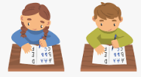

P.E

Our P.E days are Tuesday and Thursday. Please make sure your child has a P.E kit in school which is fully labelled. If your child wears earrings please ensure they are removed for P.E days.
Our units of work are: The Great Outdoors and Ball Skills.

History

In this unit of work, the children will be looking at their house and houses in the local area. We will discuss how they are different/similar and how they were built in the past.
The children will also take part in a walk around Oswaldtwistle to look at different houses.



Mathematics

Place Value
*Place Value to 50
*Place Value to 100
*Exchanging
*Partion in different ways
*1 more and 1 less
*10 more and 10 less
*Compare two numbers
*Multiples of 10

Measurement, Length and Mass
*Length and Height
*Mass
*Compare values

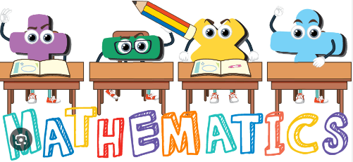
ICT

*Recognise common uses of Information Technology.
*Use technology purposefully to create, organise, store and retrieve digital content.

Music

*Learning a traditional Ghanian call and response song.
*Recognising simple notation and composing animal-based call and response rhythms.
Art and Design

In this unit the children will be investigating shade, tone and develop their observational drawing skills. They will look at different types of buildings and use different media to create their own buildings.



R.E

The Bible
*Why is the Bible such a special book?
*Why do Christians believe that the Bible is a holy book?
*The Bible is in two parts which are different – why/how are they different?
*Which Bible stories do you think are the most important? Why?
*Who uses the Bible? Why?
*Which Bible stories do you enjoy? Why?


Year 2

Autumn 1

Mrs Griffiths
Mrs Bolton

Mrs Moran
(PPA and Fridays)

Science

Living things and their habitats
During this unit of work, the children will explore and compare the differences between things that are living, dead and things that have never been alive.
They will identify that most living things live in habitats to which they are suited and describe how different habitats provide for the basic needs of different animals and plant, and also how they depend on each other.


