Science – Seasonal changes and animals including humans.
Over the Autumn term children will observe and talk about the weather and the changes between different seasons.

The Big Question! 
Remembering and Preparing

PSHE – Valuing difference
Children will identify the differences and similarities between people, know the difference between unkindness, teasing, bullying, fair and unfair and identify some of the people who are special to them.

Mathematics
This half term the children will be focussing on
Addition and Subtraction - The children will be learning their number bonds to 10, adding 10 and a single digit, solving one-step addition problems using part, whole models, subtracting single digit numbers, subtracting ten from a teens number and solving one step subtraction problems.
2D and 3D shapes – Children will name cirlces, triangles, square rectangles, oblong rectangles, spheres, pyramids, cubes and cuboids.
Sequencing and Sorting – Children will count in 5s, count in 2s, recognise and create patterns and sort objects.

Music
Over this half term the children will be learning the songs for the nativity, adding in percussion and actions.

Geography – Hot and cold places
Children will discover where countries are in the world affects how hot or cold they are, say where the Equator is and that countries closer to the North and South Poles are colder and countries closer to the Equator are hotter. They will be able to describe some of the characteristics of Antarctica and the Sahara Desert, describing similarities and differences to the United Kingdom. The children will be able to use world maps, atlases and globes.

Class notices
Please try to read with your child at home at least 3 times a week. Reading books are changed on a Tuesday and Friday.
Homework is set on a Friday to be completed by the following Friday, this will consist of maths and spellings.
Computing
Improving Mouse Skills - Learning how to login and navigate around a computer.


DT
Children will be focusing on the development mechanisms and creating an interactive Christmas card.
RE – God and Creation and Christmas
In these units children will develop their perceptions and understanding of God, reflect on feelings of awe, wonder, delight and mystery in relation to the natural world and explore what people of Muslim and Hindu faith believe about how the world was created.
In the Christmas unit we will deepen the children’s understanding of the true meaning of Christmas through emphasising that Jesus was a gift from God. Children will also discuss the thoughts and feelings associated with giving and receiving gifts.

Year 1
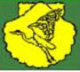
Autumn 2

Mrs Hollinshead
Mrs McLean (TA)
Mrs Moran (PPA – Tuesday AM)

PE
Tuesday AM - Gymnastics
Wednesday PM - Dance
English
Fiction – Supertato
Children will use their prediction skills, write character descriptions, create a new character, learn the story, innovate a new version of the story and independently write their new version.
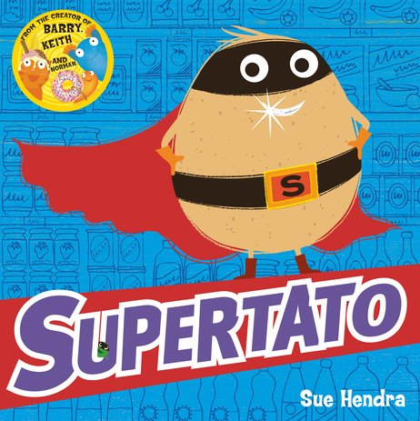
Non-Fiction – Instructions
The children will create a set of instructions for a recipe to catch the ‘evil pea’. They will use time words e.g. first, next, after. The children will also be introduced to key ‘bossy’ verbs e.g. put, get, boil.

