Science – Seasonal changes and animals including humans.
Over the Autumn term children will observe and talk about the weather and the changes between different seasons.
Children will also explore the local environment to talk about the animals in their different habitats, become familiar with the common names of some fish, amphibians, reptiles, birds and mammals and the names of places of the main body parts (head, knee, neck)

The Big Question! 
Renewal and Thanksgiving

PSHE – Me and My Relationships
Children this half term will be looking at why we have rules, how can we listen, thinking about our feelings and other people’s feelings and how we can make and keep friends.

Mathematics
This half term the children will be focussing on Place Value They will be counting, recognising and representing numbers to 30, comparing quantities and finding 1 more and 1 fewer. Measurement (Length and Mass)
They will be measuring and comparing lengths using body parts and non standard units. They will also compare and describe weight using non-standard units. Addition and Subtraction Children will recognise number bonds to 10, adding and subtracting and solving one-step problems. 2D and 3D shapes Children will name a range of 2D and 3D shapes and discuss their properties.

Music – Keeping the pulse
Children will clap/use instruments to copy the rhythm of their name, sway or tap and sing a rhythm in time with the pulse.
Geography – Hot and cold places
Children will discover where countries are in the world affects how hot or cold they are, say where the Equator is and that countries closer to the North and South Poles are colder and countries closer to the Equator are hotter. They will be able to describe some of the characteristics of Antarctica and the Sahara Desert, describing similarities and differences to the United Kingdom. The children will be able to use world maps, atlases and globes.

Class notices
Please try to read with your child at least 3 times a week. Reading books are changed on a Tuesday and Friday.
Homework is set on a Friday to be completed by the following Friday, this will consist of maths and spellings.
Computing
Online Safety

ART
Children will be focusing on the development of observational skills. They will explore the art of Pablo Picasso.
RE – Harvest
Over this half term the children will develop an understanding that Harvest festivals are a traditional celebration to give thanks to God for the gifts of the harvest. Have an increased awareness that the food we eat is harvested and distributed all around the world. Raise awareness and that in the UK our harvest is usually plenty but in some other countries around the world the harvest fails. Discuss what the response of Christians should be to the need of others. Finishing the unit exploring the Jewish festival of Sukkot.

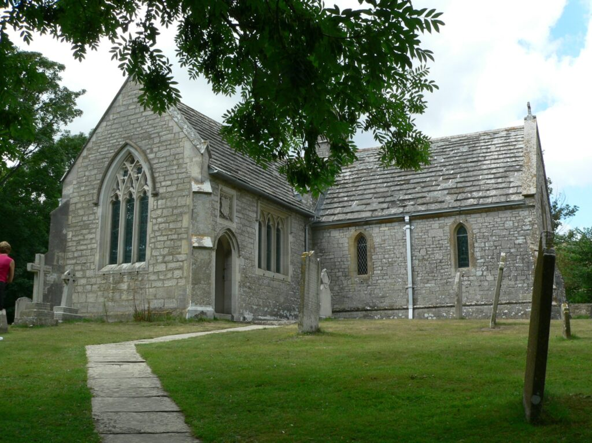

Year 1
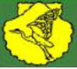
Autumn 1

Mrs Hollinshead
Mrs McLean (TA)
Mrs Moran (Tuesday AM)

PE (Tuesday Morning and Wednesday afternoons)
NO earrings to be worn on this day please.
Lost and Found. (hopping/skipping/throwing/catching/running/jumping)
English
Fiction – Harry the Happy Mouse
Children will look, say and sing a range of songs and rhymes that are new and familiar. They will be focussing on the story of Harry the Happy Mouse and will make predictions, write character descriptions, sequence events, learn a story and innovate the story to create their own.
Non-Fiction – Information text
The children will create an information text on an animal. They will identify parts of non-fiction information posters (title, subheading, labels and captions), use new vocabulary and question marks.

